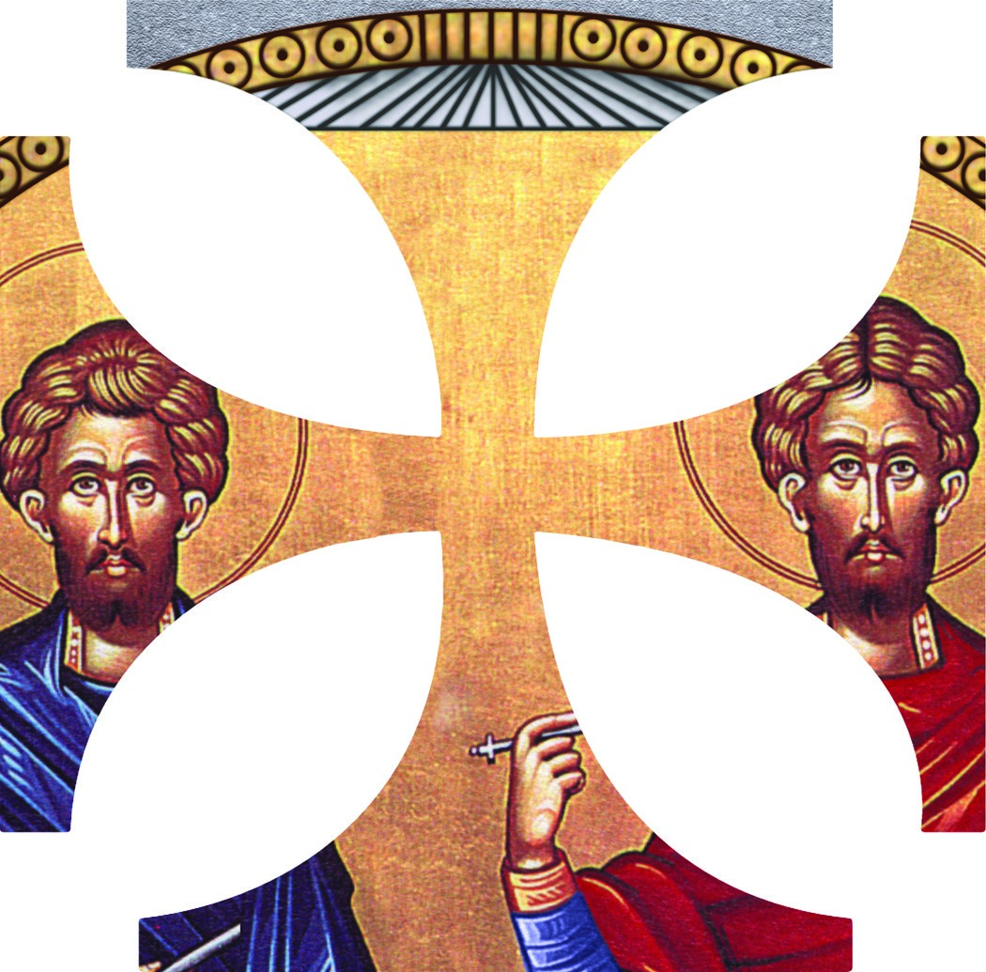
St. Irene Philoptochos
Scholarship
DEGREE OF PARTICIPATION AT ST. JOHN THE BAPTIST PARISH
(Choose 9 of the choices below to = 45%) Each selection is worth 5%

- Sunday school attendance at least 70%. To be determined by Sunday school teacher.
- Participate in at least 3 GOYA fund raisers.
- Write an essay for the Oratorical Festival.
- Attend camp Emmanuel.
- Help out at vacation bible school.
- Attend GOYA advent and or Great Lenten Retreat.
- Take part in church sponsored community service projects.
- Active participation in their Sunday school class.
- Serve on the altar or serve as a Myrophore at Easter
- Basketball or other intermural church sponsored tournament.
- Youth dancing.
Scholarship: GPA = 40%
  - A = 40%
  - B = 30%
  - C = 20%
  - D = 10%
Essay Question:
- How will you keep your Orthodox faith? = 7.5%
- How will you maintain your Orthodox Values? = 7.5%

