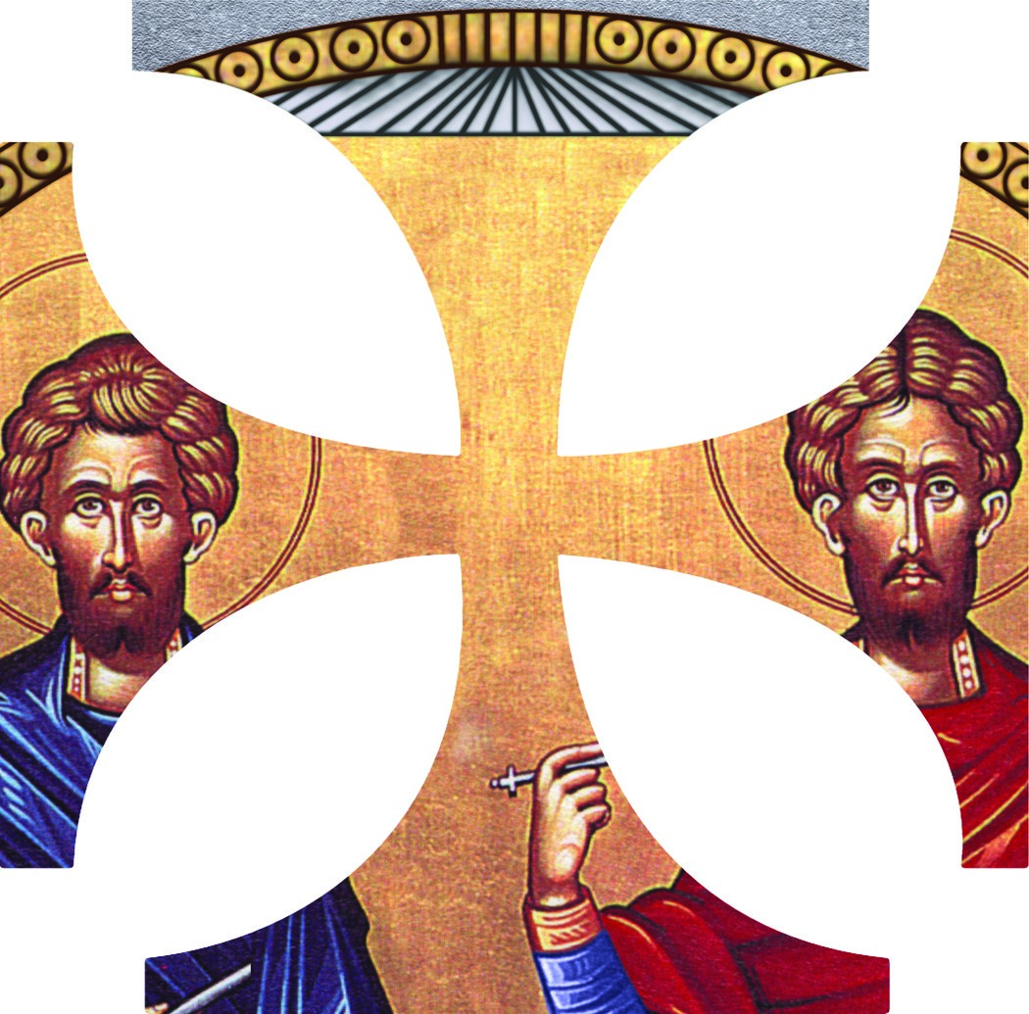 ST. IRENE PHILOPTOCHOS SCHOLARSHIP
St. John the Baptist Greek Orthodox Church
303 Cullum Drive, Euless, Texas 76040
Instructions and Information
Eligibility Requirements:
At least one parent of the applicant must be meet stewardship requirements of St. John the Baptist Greek Orthodox Church for the previous and current calendar year.
Or
Was an active member in another Orthodox parish and then became a steward of St. John’s during the above mentioned time frame.
- The applicant must be an Orthodox Christian.
- The applicant must be a high school senior, graduating in the current academic year (i.e., August – July), entering higher education (2 or 4 year or trade school), as a full time student.
Selection Criteria:
- The scholarship will be awarded based on a weighted average as follows:
  - Degree of participation at St. John the Baptist parish 45%
  - Scholarship (GPA) 40%
  - Essay Question: 15%
Process Milestones:
- Applications will be available for distribution the first Sunday in February.
- Applications are due in to the Scholarship Chairperson no later than the last Sunday in March.
- Selection process begins the first week of April.
- Notification of the award will be the last Sunday in April.
Rules:
- In the event there is no scholarship awarded due to a lack of eligible applications, the award money will remain in the Philoptochos Scholarship Fund account.
- In the event the award recipient decides not to enroll in a school of higher education prior to the 1st semester after granting the scholarship, it will be offered to the runner-up if one is named. Otherwise, the award money is to remain in the Philoptochos Scholarship Fund account.
- The scholarship amount will be granted once the Scholarship Committee receives a copy of the award recipient’s registration receipt.

ST. IRENE PHILOPTOCHOS SCHOLARSHIP
St. John the Baptist Greek Orthodox Church
303 Cullum Drive, Euless, Texas 76040
APPLICATION FORM

Date: ___/___/___

Last Name: ______________ First Name: ________________ M.I. _____
Address: ___________________________________________________________
City: ____________________ State: ____________________ Zip: _____
Phone (H): ___-___-___ Phone (C): ___-___-___ Email: ________________
Date of Birth: ____ / ____ / ____
Mother’s Name: _____________________________________________________
Father’s Name: ______________________________________________________
High School: _______________________________________________________
Graduation Date: ____ / ____ / ____ GPA: ______
Institution you plan to attend:
Name: ____________________________________________________________
Address: ___________________________________________________________
I have ______ have not ______ been accepted. Entry Date: ____ / ____ /_____
- Attach a copy of your current transcript.
- Include a letter of recommendation.
- Print or type response to essay question.

**** All information is confidential and is reviewed by the Scholarship Selection Committee.

ST. IRENE PHILOPTOCHOS SCHOLARSHIP
St. John the Baptist Greek Orthodox Church
303 Cullum Drive, Euless, Texas 76040
Applicant: _____________________________________
List your participation in the life of St. John the Baptist and or any other Orthodox church – include the years.
_____________________________________________________________________________________________________________________________________________________________________________________________________________________________________________________________________________________________________________________________________________________________________________________________________________________________________________________________________________________________________________________________________________________________________________________________________________________________________________________________________________________________________________________
_______________________________________________________________________________________________________________________________________________________________________________________________________________________________________________________________________________________________________________________________________________
Essay Question: Please complete on a separate piece of paper.
As a college student, how will you keep your Orthodox faith? You may be living away from home and you will certainly be exposed to new ideas, how will you maintain your Orthodox values?

